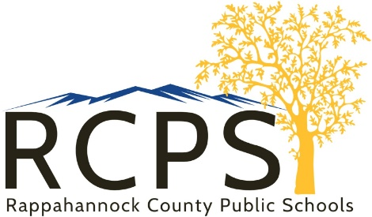

School Board Office

6 Schoolhouse Road

Washington, Virginia 22747

Telephone (540) 227-0023

Fax (540) 987-8896

[www.rappahannockschools.us](http://www.rappahannockschools.us)

**ONLINE FREE AND REDUCED MEAL APPLICATION**



Dear Parent/Guardian,

You can now apply online for your student(s) to receive free or reduced priced school meals. Your application will be sent from a secure website directly to Rappahannock County Public Schools so you will not need to fill out the paper form.

Please visit [www.LunchApplication.com](http://www.LunchApplication.com) where the process is designed to make it easy by collecting only the information that is needed. Once your application has been received, the school board office will determine your child(ren)’s eligibility and will send you a letter with the results.

The online application is an easy, secure, and convenient way to apply for free or reduced priced meals. To apply, simply go to [www.LunchApplication.com](http://www.LunchApplication.com) and Click Apply Now.

[](https://www.lunchapplication.com/)

If you have any questions, please contact Amanda Butler at 540-227-0023 or [abutler@rappahannockschools.us](mailto:abutler@rappahannockschools.us)